Rationale Document for the Logical Data Model:
Ground-Warfighter Geospatial Data Model (GGDM) version 2.2

Report Date: December 20, 2013

Contract No W5J9CQ-12-D-0004 Task Order 0008
Unclassified

SAIC, Geo-Spatial Technologies & Information Division

Author:
Annette Janett Filer, SAIC

Contributors:
Robert (Bob) Gaines, SAIC
Nancy Towne, U.S. Army Geospatial Center
Dr. Dale D. Miller, SAIC
Dr. Barry Schimpf, Zekiah Technologies, Inc

Prepared for:
U.S. Army Geospatial Center

Document Revisions:
- December 5, 2011 GGDM 2.1
- December 20, 2013 GGDM 2.2

Table of Contents
1. Introduction 1
2. Referenced Documents 1
3. Objectives 2
4. Data Modeling 3
5. Process 4
Component Models 4
Logical GGDM 4
Data Dictionary 4
Physical GGDM 5
Change Requests / Comment Adjudication 5
Quality Assurance 5
6. GGDM Components and Component Models 6
7. Statistics 7
8. Data Model Deliverables 8
Logical Data Model 8
Physical Data Model 9
9. Special Considerations 9
10. Next Steps 9

Table of Figures
Figure 1 GGDM Domains 1
Figure 2 GGDM Development Process 4
Figure 3 GGDM Components 6
Figure 4 Geometry Allocation Venn Diagram 7

Table of Tables
Table 1 GGDM Data Dictionary 6
Table 2 Feature, attribute, and domain value totals 7
Table 3 Feature geometry allocation 7
Table 4 Allocation of features to configuration levels 8

Acronyms
This document and associated release materials will make use of several acronyms.

AGC Army Geospatial Center
AGE Army Geospatial Enterprise
AGDM Army Geospatial Data Model
CDMF Common Data Model Framework
CCB Configuration Control Board
COI Community of Interest
DCS Data Content Specification
DFDD DGIWG Feature Data Dictionary
DGIWG Defense Geospatial Information Working Group
EC Entity Catalog
ERS Engineering Route Studies
Esri Environmental Systems Research Institute, Inc.
FACC DGIWG Feature and Attribute Coding Catalog
GGDM Ground-Warfighter Geospatial Data Model
HTML Hyper Text Markup Language
LDM Logical Data Model
NFDD NSG Feature Data Dictionary
NGA National Geospatial-Intelligence Agency
NSG National System for Geospatial-Intelligence
PDM Physical Data Model
PIM Platform Independent Model
QA/QC Quality Assurance/Quality Control
SDSFIE Spatial Data Standards for Facilities, Infrastructure, and the Environment
SME Subject Matter Expert
TDS Topographic Data Store
TGD Theater Geospatial Database
TGD GPC Theater Geospatial Database Geospatial Planning Cell
UML Unified Modeling Language
USMC U.S. Marine Corps
UTP Urban Tactical Planner
WRDB Water Resources Data Base

Introduction
The Ground-Warfighter Geospatial Data Model (GGDM) is a core component of the Army Geospatial Enterprise (AGE) as developed by the U.S. Army Geospatial Center (AGC). The goal of the AGE is to provide standards and technology to acquire, manage, and share geospatial data, for the warfighter in order to eliminate stovepipes, reduce costs, simplify acquisition and accelerate transition of technology as part of a standard and shareable geospatial foundation. As the core component of the AGE architecture, the GGDM offers consistent and efficient development of logical and physical data models supporting ground-warfighter geospatial concepts.
The primary focus of the GGDM is to identify, understand and manage geospatial data entities, information concepts, structural relationships, and lineage information in a shareable, accessible common environment for ground forces. The GGDM supports the ground-warfighter within the AGE with a well-defined interoperable schema, data dictionary, and databases that provide a common operational picture for mission command while reducing cost due to reuse and automated processes. The GGDM is not a static model; rather it is expected to evolve to include a wider range of concepts important to the ground warfighter including concepts in additional domains such as tactical, aeronautical, maritime and building interiors.
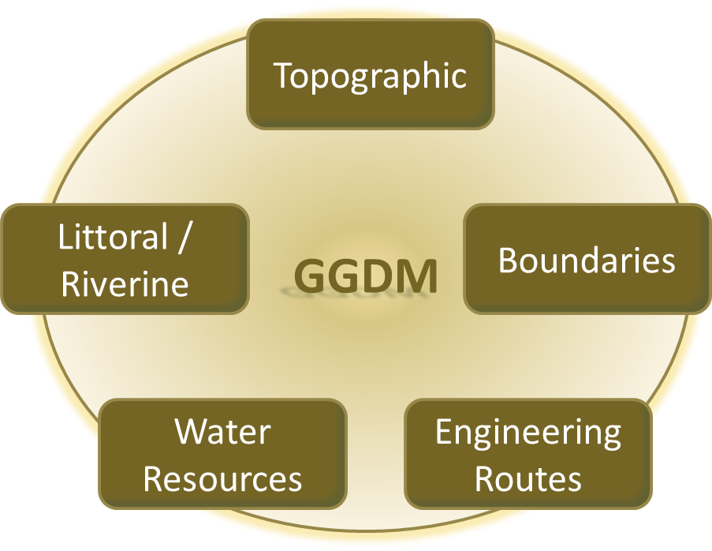
The GGDM information domains (as shown in Figure 1) currently include:
Figure 1 GGDM Domains
- Topographic – Primarily based on the National System for Geospatial-Intelligence (NSG) Topographic Data Store (TDS) Data Content Specification (DCS), but also including concepts from Theater Geospatial Database Geospatial Planning Cells (TGD GPC), and U.S. Marine Corps (USMC).
- Boundaries – Based on National Geospatial-Intelligence Agency (NGA) drafts of their Names and Boundaries Data Store, with additional information from Army and USMC.
- Engineering Routes – Based on AGC’s Engineering Route Studies (ERS)
- Water Resources – Based on AGC’s Water Resources Database (WRDB)
Littoral / Riverine – Based on NGA drafts of the Maritime and Aeronautical Data Stores, with additional information from Army and USMC.
The GGDM consists of a logical data model (LDM) schema, a data dictionary, and physical data model (PDM) exemplars intended to support enterprise-wide geoservices across Army and Warfighter Programs. These data models are designed for the collection, maintenance, and dissemination of vector data including features such as roads, rivers, buildings, fences and bridges; and identifying attributes related to the features such as function, height, type, physical condition and operational status; and metadata describing the accuracy, content origin, and classification level. The GGDM is the ground-warfighter container into which geospatial data elements may be collected, managed and reused. It provides for unique ground-warfighter extensions falling outside traditional data products to be rapidly included into the model and be made available to ground-warfighter systems. The GGDM also features a tight-coupling with the NSG TDS allowing for greater interoperability and data sharing between the GGDM and NGA’s NSG TDS.

Referenced Documents
Additional information on the GGDM and the TDS is found in the following documents:
- Topographic Data Store Entity Catalog (TDS EC) Version 6.0, National Geospatial-Intelligence Agency.
- Global Topographic Data Store Extraction Guide (GTDS EG) Version 6.0, National Geospatial-Intelligence Agency.
- Regional Topographic Data Store Extraction Guide (RTDS EG) Version 6.0, National Geospatial-Intelligence Agency.
- Local Topographic Data Store Extraction Guide (LTDS EG) Version 6.0, National Geospatial-Intelligence Agency.
- Specialized-Urban Topographic Data Store Extraction Guide (S-UTDS EG) Version 6.0, National Geospatial-Intelligence Agency.
- GGDM Executive Summary Version 2.2
- GGDM Entity Catalog Version 2.2
- GGDM Rationale Appendix – Component Models Version 2.2
- GGDM Rationale Appendix – Concept Mappings Version 2.2
- GGDM Rationale Appendix – Consistency Version 2.2
- GGDM Rationale Appendix – Data Modeling Version 2.2
- GGDM Rationale Appendix – Extensions Version 2.2
- GGDM Rationale Appendix – Metadata Version 2.2
- GGDM Rationale Appendix – Physical Data Model Version 2.2
- GGDM Rationale Appendix – Quality Assurance Version 2.2

Objectives
The strategy for developing the GGDM is to iteratively evolve the model through the incorporation of geospatial data requirements and existing datasets that are authoritatively advocated by the ground warfighter Community of Interest (COI), to include existing Army programs of record, future Army acquisitions and key data collections of service to the ground warfighter. These data requirements are embodied within LDMs and PDMs. The objective data model, the GGDM can conceptually be thought of as an adjudicated union of these component data models/datasets.

The overall objective in the development of the GGDM is to provide a logical and physical model representative of ground warfighter core geospatial data requirements. There are two key developmental areas needed to accomplish this objective:
1) Development of a LDM representative of the core components that has been re-organized, adjudicated, grouped for human review, adjusted for consistency, and abstracted in cases where a number of specific concepts could be merged into one concept.
2) Development of one or more exemplary PDMs representative of the LDM that enables support by various enterprise level geoservices, and allows for physical synchronization with the NSG TDS implementation.

The secondary objective in the development of the GGDM is to establish automated processes by which the logical model can be transformed into a physical model. The specific goal is to develop tools that automatically generate an Environmental Systems Research Institute, Inc. (Esri) Geodatabase from the LDM that matches the selected sample physical model (NSG TDS implementation). With implementation of automated logical to physical transformations, edits to the logical model are propagated accurately to the physical model in a time efficient, repeatable and correct manner.
GOALS
- Represent COI concepts in logical and physical model
- Establish automated processes
- Physical model to be ‘synchronizable’ with NSG TDS
- Extensions to be consistent with NSG schemas and catalogs

In addition to the high level objectives described above, the GGDM development is subject to several key objectives that impact requirements, design, implementation, and production of the GGDM:

NSG TDS and synchronization
The primary component model used to form the GGDM is the NSG TDS. The GGDM contains all of the NSG TDS concepts (at a specified revision) and extended concepts. This tight coupling between the GGDM and the NSG TDS allows for the potential of data sharing between these two models and a key objective of the GGDM effort is to allow for this data sharing (e.g. synchronization) to occur at the physical level. This data sharing/synchronization objective places a number of constraints on the GGDM, including conformance to naming and typing conventions, feature organization, and limitations to implementation of certain extensions.

Component models and consistency
In addition to the NSG TDS, the GGDM contains concepts from other component data models, data sets, and specific requirements from Subject Matter Experts (SMEs). These concepts are represented in the GGDM in a manner that is consistent with the NSG TDS, and other NSG schemas and catalogs. Modeling of component information in a manner that is consistent with the NSG TDS requires both direct and subtle changes to the original component concepts. In order to ensure a uniform approach, consistency rules are used when adding and adjudicating concepts into the GGDM. These rules are documented in the appendix titled “GGDM 2.2 RationaleAppendix Consistency.doc”.

Data Modeling
The GGDM is a representation of geospatial information for the Army established to define, document and maintain ground-warfighter geospatial data information requirements. The model is expected to be used in automation and information products. Therefore, it is common practice to establish a formal process that incrementally refines formal representations that incorporate more detail to produce an automation or information product.

The data modeling team followed the established approach in development of the GGDM. Using data sets and/or schemas provided by the government, the team reverse engineered these data sets and identified underlying information concepts. When possible, the team produced a LDM representative of the original content. In some cases the team had to use mappings to translate the original content into a new data dictionary. Ultimately each data set originally specified as a component for the GGDM was represented logically as a set of features with geometry type, attributes with default values, attribute domain value constraints, and relationships between features (when present). Additional details describing standard logical data modeling practices and how they are applied to build the GGDM are described the appendix titled “GGDM 2.2 RationaleAppendix Data Modeling.doc”.

Automated data modeling tools were instrumental in the development of the GGDM. Given the number of data schemas, data requirements, the complexity of the data schemas, the mappings involved, and the general nature of geospatial data content, the use of interactive modeling tools to lay out every feature (with properties), attribute (with properties), and attribute domain value in Unified Modeling Language (UML) would be inefficient and error prone. Instead, the focus was on development on automated tools that:
- extract data requirements from exemplary data set templates, schemas or data specifications
- generate logical model frameworks from collections of data requirements
- help SMEs and data modelers with adjudication, ensuring consistency, and review of the model
- translate the model from logical to physical form
- generate physical models of multiple formats and styles
- generate statistics and documentation
- perform validation tests

The efficacy of this approach was demonstrated by the rapid turnaround of the TDS 3.0 data specification (July 2010) into the Army Geospatial Data Model (AGDM) 2.0 (late September, 2010). A three month turn-around for integration of data content specifications into logical and physical models for a project this complex seems impossible without the use of such automated tools.

Process
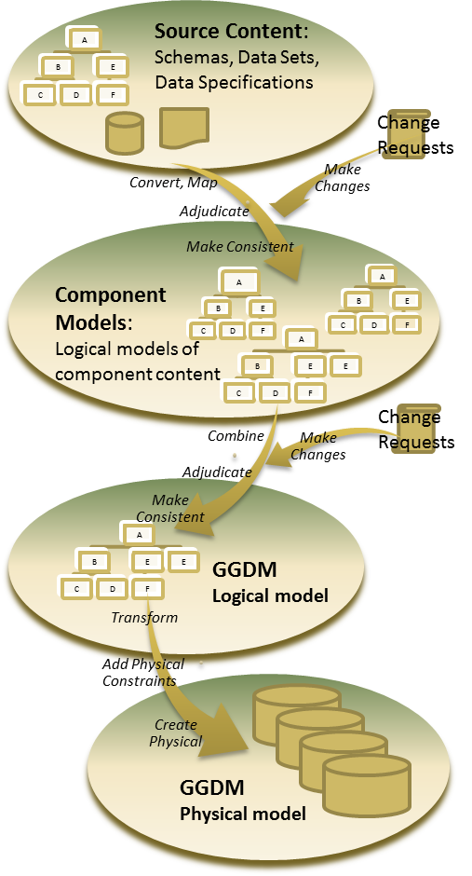
The GGDM development starts from source content including data sets, specifications, data models, and/or schemas. Optimally, logical models representative of the entire stakeholder source content requirement are created. It is preferable to work with the full stakeholder requirement set rather than a subset so the lineage, traceability, and mappings can be managed for all of the concepts and changes made to TDS or GGDM. Once all stakeholder models are present, the stakeholder component models are merged to form the GGDM. Several consistency adjustments are made to ensure the model is consistent with the NSG TDS and to allow for automated logical to physical transformations. The physical models of the GGDM are then generated. This process is graphically illustrated in Figure 2.
Figure 2 GGDM Development Process

Component Models
In many cases stakeholder information is modeled as a Common Data Model Framework (CDMF) compliant LDM. In other cases the stakeholder information must be mapped, refined, adjudicated and modeled. The mappings involve dictionary concepts, schema information, and data modeling constraints along with SME input and significant checking, re-checking and adjustments over time. Specifics about the mapping efforts undertaken for the GGDM can be found in the appendix titled “GGDM 2.2 RationaleAppendix Concept Mappings.doc”. Once a CDMF compliant LDM has been created that represents the stakeholder information, ancillary attribute information and naming rules are added to generate a “physical specification” which is used to generate the PDM and GGDM Entity Catalog (EC). The GGDM EC format is comparable to the TDS DCS Entity Catalog (EC). Additional details regarding this “physical specification” and the process of assigning ancillary attribute information can be found in the appendices titled “GGDM 2.2 RationaleAppendix Data Modeling.doc” and “GGDM 2.2 RationaleAppendix Physical Data Model.doc”. The consistency processing step uses semi-automated tools to evaluate the model consistency as per the consistency guidelines discussed in the appendix “GGDM 2.2 RationaleAppendix Consistency.doc”.

The specific component models making up the GGDM 2.2 are described in detail in the appendix document “GGDM 2.2 RationaleAppendix Component Models.doc”.

Logical GGDM
Upon completion of a baseline set of component LDMs and validation of each component model, all relevant component models are merged together into a single LDM. Automated tools are used to assign feature groups, feature numbers, and perform consistency corrections and integrity corrections on the final LDM to ensure the model is complete, correct and accurate. Upon completion of all consistency/corrective actions the tools provide for processes to translate logically defined attributes into a physical specification (as discussed in the appendix “GGDM 2.2 RationaleAppendix Data Modeling.doc”). The final step in creating the LDM is to generate the overview reports, statistical results, and UML from tools.

Data Dictionary
The GGDM data model is based on the same NSG Feature Data Dictionary (NFDD) version used for the TDS. There are also extensions to the NFDD dictionary provided in the GGDM to address concepts that are:
- Found in the GGDM and not expected to be provided in NFDD
- Proposed as NFDD additions and are in the process of being incorporated into NFDD

When dictionary extensions are included in the GGDM a step-by-step process is used to identify the extensions and/or define the extended concept:
- Use the concept if it is in the NFDD and is to be used as per the NFDD definition.
- Utilize the Defense Geospatial Information Working Group (DGIWG) Feature Data Dictionary (DFDD)
- Utilize other published dictionaries such as DGIWG Feature and Attribute Coding Catalog (FACC).
- Define a new concept if there is no available dictionary resource from which to draw the concept (flag with the stakeholder identification).

Every attempt is made to ensure the concept has a “good” definition, however since extended concepts may originate from stakeholders, definitions are found to be less than optimal at times. Sometimes this has ultimately resulted in the removal of the concept (if the original stakeholder can not defend it) and at other times the concept is retained with a poor definition because of the importance of the concept. The LDM delivery content includes a report describing the data dictionary for the GGDM identifying all concepts used in the GGDM and their source.

Physical GGDM
The physical model is generated using software originally developed by Zekiah Technologies, Inc (formerly Upper-90 Systems, Inc) for the Spatial Data Standards for Facilities, Infrastructure, and the Environment (SDSFIE). These software tools were modified to address specific requirements of the GGDM. In particular, changes were implemented so the resulting model would be similar to existing Esri implementations of the TDS with some exceptions that will not affect synchronization but will reduce the size and complexity of the GGDM physical database. Exceptions include:
- A single (GGDM_Boolean_enum) domain list is specified for all of the “Boolean” attributes
- Attributes having cardinality greater than 1 share a single domain list
- Attribute domain lists are shared across features having different geometry
- Code list attributes each refer to the single model-wide domain list that is generated based on the html link provided in the NSG TDS EC plus any additional domain values listed in the NSG TDS EC (e.g., no information, other).

The PDM generation tools read the logical data model content from the CDMF compliant GGDM LDM and then create a non-vendor specific data specification, the Platform Independent Model (PIM). The PIM provides for a non-vendor specific set of common data elements organized and aggregated in a manner that makes the content more easily translated into a variety of vendor specific formats. Once the specific desired format has been selected, tools are used to apply vendor specific constraints to the model. The PDM generation tools create the specified vendor format, in this case Esri File Geodatabases, from the PIM. The development of the physical model is described in more detail in the appendix titled “GGDM 2.2 RationaleAppendix Physical Data Model.doc”.

Change Requests / Comment Adjudication
The GGDM 2.2 is currently managed by AGC’s GASD and version-controlled and adjudicated by the AGE Configuration Control Board (CCB) with representation across the AGE COI. The configuration management of the GGDM is managed by the Ground-Warfighter Working Group chartered under the NSG Geospatial Working Group.

Over the course of GGDM development, comments and suggestions based on the draft or a previous release of the model are received. Change requests and comments may apply to any part of the model at any stage of the process. When the comment or report is received in a textual document, responses are provided back to the commenter in a similar document. Comment and response information that result in change requests are placed into a GGDM Change Request document where the GGDM team details the change request information, document the implementation details, and document change request approval or non-approval.

Quality Assurance
One key measure of success of the GGDM processes is to ensure the results are quality controlled. To meet the required level of quality, a Quality Assurance/Quality Control (QA/QC) Plan documents the quality assurance goals and processes for the GGDM (see the appendix titled “GGDM 2.2 RationaleAppendix Quality Assurance.doc”).

A major stakeholder component in the GGDM is the TDS, and it is important to ensure the GGDM fully contains the TDS. To test for this, a query-based test tool is executed to compare the LDM against the TDS EC and report differences. The comparison tools are part of the quality assurance processes executed with each release of the GGDM.

GGDM Components and Component Models
Over time, the GGDM has evolved to include new component models and has been updated to include new revisions of component models. This is shown graphically in Figure 3. Details about these component models are documented in the appendix titled “GGDM 2.2 RationaleAppendix Component Models.doc”.
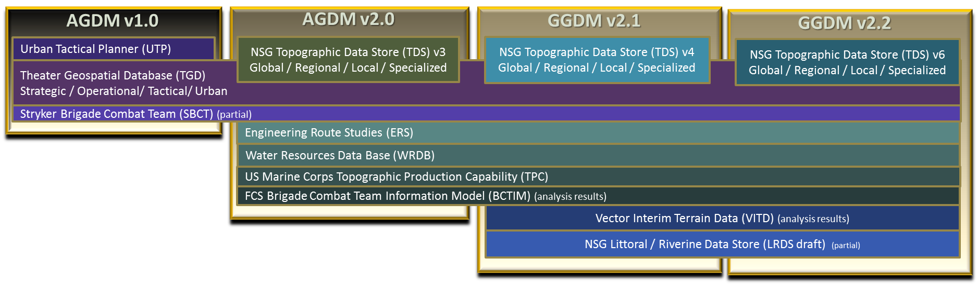
Figure 3 GGDM Components

In addition to stakeholder components, the baseline GGDM data dictionary has changed as the model evolves. Generally the GGDM uses the same data dictionary as the NSG. The baseline data dictionary for each revision of the GGDM is shown in Table 1 below.

Table 1 GGDM Data Dictionary
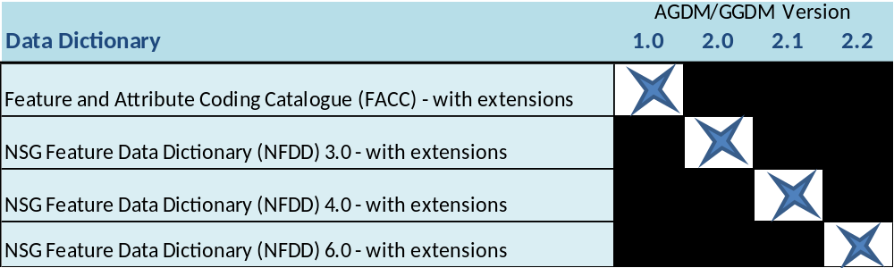

The GGDM development extends the baseline data dictionary with concepts required in non-TDS core components. The GGDM uses the combination of the baseline data dictionary and extended concepts to extend the data model beyond the TDS baseline as per requirements from core contributors.

Feature / Entity concept extensions in the GGDM include:
- Military Boundary (STBM1). Attribution on this concept requires similar attributes to Administrative Boundary with an additional attribute specifying military boundary type. The definition for this extended concept is from Joint Publication (JP) 3-0: “A line that delineates surface areas for the purpose of facilitating coordination and deconfliction of operations between adjacent units, formations, or areas.”
- Landing Zone (STB23). Originally in the GGDM as a Stryker Brigade Combat Team requirement this has become important to TGD GPCs as well as other GGDM users. This concept was submitted to TDS CCB for consideration but the TDS CCB declined to add it as it was felt to be an “aeronautical” domain concept.

Attribute concept extensions in the GGDM include:
- Geometry (Horizontal) : Horizontal Accuracy Category (ZI010_ACC). Used for metadata purposes this concept is found in the NFDD but it is not used in TDS. GGDM added it to the Feature Metadata entity.
- Water Resource Information : Purification Process (ZI024_PUR). An extension provided for the WRDB component, currently found in neither NFDD nor DFDD.
- Snow or Ice Depth (SND). An extension requested by USMC, this is a new attribute in the GGDM that is not found in any associated standard dictionary.
- Hospital Bed Count (HSC). An extension required for the Army, this concept is in DFDD, but is not in NFDD or TDS.

The full list extensions found in the GGDM that are not part of the base component NSG TDS are documented in the appendix titled “GGDM 2.2 RationaleAppendix Extensions.doc”.

Statistics
The total number of geometric features, the unique attributes, the feature attributes from both the logical and the physical perspective for the GGDM 2.2 are described in this section.
Table 2 Feature, attribute, and domain value totals
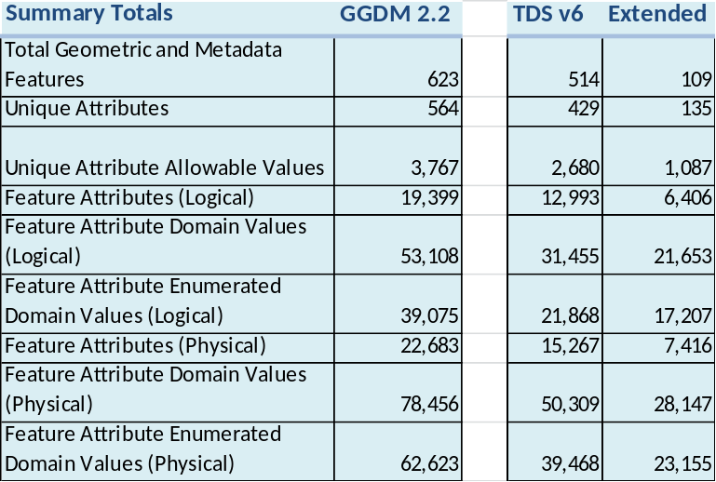

Since the GGDM 2.2 is based upon the NSG TDS 6.0, when it is feasible to show the corresponding statistics for NSG TDS 6.0, these values are identified using the term “Baseline” while content representative of GGDM extensions to the TDS baseline uses the heading “Extended”.

Table 2 shows GGDM 2.2 and separately shows NSG TDS 6.0 (baseline), and extensions to NSG TDS statistics found in the GGDM 2.2. The table includes total features, unique attributes across the entire model, unique domain values across the entire model, and feature attribute information from the logical perspective where attributes having multiple cardinality are denoted once and interval attributes are denoted once. Counts for physical feature attributes are also provided in which attributes have been propagated into a form that matches the field names found in the physical database (for example, the logical interval attribute has been propagated into its physical form in which three fields will be included in the physical database).

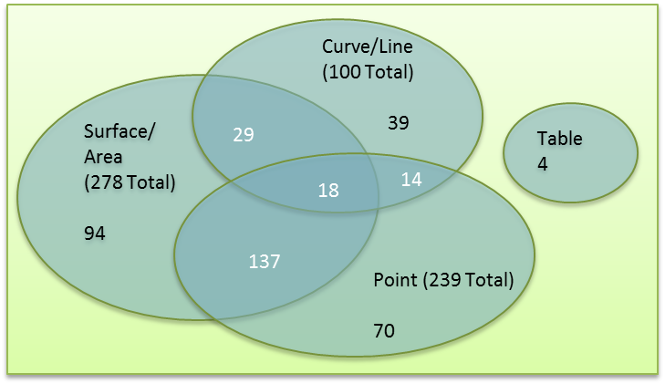
Geometric representation of features is a key discriminator in geospatial data models and geospatial databases. Table 3 provides the basic number of geometry types found in GGDM and breaks out the values corresponding to NSG TDS and those that are extensions in the GGDM. Recall that a feature code can be used with varied geometric representation. This variation results in overlap meaning that some features are represented as all three geometries. The level of geometric overlap in the GGDM is illustrated in Figure 4.
Figure 4 Geometry Allocation Venn Diagram

Table 3 Feature Geometry Allocation
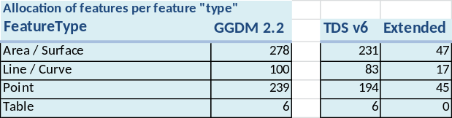

The physical representations of the GGDM are based on the configuration levels: Global, Regional, Local, and Specialized. These configuration levels follow the guidelines established by the NSG TDS:
- Global contains content typically included in topographic datasets/maps at scales of 1:400,000 and smaller;
- Regional contains content typically included in topographic datasets/maps at scales ranging greater than 1:200,000 up to 1:399,000;
- Local contains content typically included in topographic datasets/maps at scales ranging from 1:24,000 to 1:200,000; and
- Specialized-Urban contains content typically included in topographic datasets/maps at scales larger than 1:24,000.

Table 4 Allocation of features to configuration levels
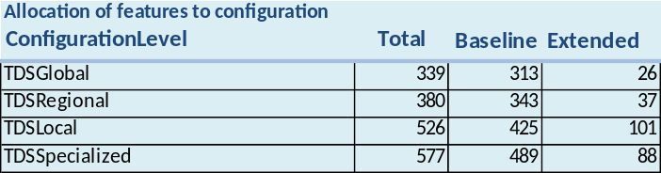

The allocation of features to configuration levels is described in detail in the Entity Catalog document found with the logical model information titled “GGDM 2.2 Entity Catalog.xls”. Table 4 describes the total number of features found in each configuration level and includes a breakout of features counts coming from the TDS (Baseline) and those that are extended.

Data Model Deliverables

Two data model deliverables are associated with the GGDM. First, the LDM captures the important data content by describing the semantic information of compliant data sets in a logical manner. The LDM is the basis for the second deliverable, one or more PDMs, which fully explicate the syntactical representation in one or more database formats. The LDM captures the data elements, but does not specify specific implementation details such as data type, word length, or word alignment. The LDM describes the data requirements from a particular perspective and there could be many valid, but different LDMs that capture the same data elements, potentially at different levels of abstraction. The LDM helps humans understand the semantics of the data elements and requirements and facilitates communication and process improvement and is invaluable in analysis of the level of overlap between different models. The PDMs provide for exemplary databases ready to receive data and operate within a geospatially enabled environment. The PDM is required for data analysis, data collection, and data repositories within geospatial systems such as the AGE. Some experts in the geospatial field are more comfortable examining the PDM rather than the LDM, while others are more comfortable with the LDM description such as the Entity Catalog.

Logical Data Model
The logical data model for geospatial systems contains hundreds of features, thousands of attributes, and tens of thousands of enumerated domain values. Viewing the GGMD UML model in a UML diagram does not allow for optimal human dissemination of the information. Therefore, all GGDM releases include summary reports and detailed content in addition to UML, including:
- PDF format report summarizing the features and attributes in a non-graphical report form.
- PDF format report detailing features, attributes, domain values and relationships at the logical level.
- Microsoft® Excel™ format spreadsheet detailing features, attributes, domain values, levels, and groups in an “Entity Catalog” format similar to the TDS DCS Entity Catalog documents.
- Microsoft Access™ database (MDB) file describing features attributes and domain values in simplified tables.
- PDF format Data Dictionary report identifying concepts used in the data model and their sources.
- Microsoft Access database (MDB) Common Data Model Framework (CDMF) compliant LDM.

Physical Data Model
The PDM generation tools restructure the GGDM LDM into a PIM database which provides common elements independent of any specific implementation format. PDM generation tools translate the PIM into a specific implementation, a PDM. The tools can output the model into various specific formats including: Esri Geodatabase, Oracle Spatial, Bentley Map, AutoCAD Map, and PostGres.

The GGDM is currently developed as an Esri File Geodatabase format. The tools generate several geodatabases for the GGDM:
- Unioned GGDM: A Geodatabase including all features and all attributes for all configuration levels in one database
- Global: A Geodatabase containing concepts allocated to the Global configuration level
- Regional: A Geodatabase containing concepts allocated to the Regional configuration level
- Local: A Geodatabase containing concepts allocated to the Local configuration level
- Specialized (Urban): A Geodatabase containing concepts allocated to the Specialized configuration level

In addition to these geodatabases, the generation of test databases with alternative grouping schemes is supported to support test and analysis of alternative database structures.

Special Considerations
This section describes special considerations unique to this revision of the GGDM. Code lists are highlighted again because some attributes that seem to be possible code lists are instead defined as strings. When a code list can consist of multiple values picked from the lists then the GGDM cannot tie the domain list to the attribute. An application level utility will have to concatenate the selected picks from the list into a string attribute.

Code Lists – When a code list attribute consists of a single value then the process for handling the code list enumerated domain values is better defined:
- Each unique code list enumerated property will be retained in a single model-wide domain list
- The domain list is constructed as follows:
  - Reading the HTML page and extracting the content;
  - Including additional domain values from the NSG TDS EC.
Note: The NSG TDS release may include a spreadsheet listing the values from the HTML page, but this spreadsheet is not considered to be the authoritative source of the information, therefore it is not used.
- An application will periodically (or on command), check the HTML pages corresponding to code list attributes for updates. This application will create a Python® script that can be applied to the GGDM databases to update the internal domain lists with the updated values.
- The Python script will be distributed to GGDM database sites to update the physical databases.

Domain Value Extensions – GGDM 2.2 contains no extended domain values on feature / attributes that have lineage to the TDS. This is done because when the GGDM is synchronized with the TDS, any extended domain values that are used, would be flagged by the data validity checkers as erroneous because they do not match the TDS domain value list. Therefore, all extended domain values are removed from this GGDM and retained separately where they will be evaluated for potential TDS CCB actions. In the meantime, GGDM users do have the ability to specify extended domain values via the use of the “Specified Domain Values(s)” (OTH) attribute that is present on every feature.

Areas of Numerous – This GGDM contains specific area / surface features for handling areas containing multiple feature instances that are captured as a single geometric area instance.

Next Steps
The GGDM team continues to respond to ground-warfighter areas of need and comments and suggestions are accepted at any time. Please see the document “GGDM CCB BLANKTEMPLATE.doc” for a blank template comment form. In addition to submitted comments, the GGDM team continues to document and refine rationale and lineage for extensions and submits many extensions to standards bodies for potential inclusion in other standards such as NSG TDS or DFDD.

Future versions of the GGDM may include updates based on generating force enterprise activities, including high resolution urban information, modeling and simulation, installations, tactical information and updates based on common geospatial data requirements across the Army, USMC and other ground forces components.

An Objective Process for the Development, Deployment and Maintenance of the Geospatial Army Data Model, SAIC and Upper-90 Systems, Inc., October 10, 2008

